Stock span problem
Mark as Completed
0
Problem Statement: Given an array arr of size n, where each element arr[i] represents the stock price on day i. Calculate the span of stock prices for each day.
The span Sᵢ for a specific day i is defined as the maximum number of consecutive previous days (including the current day) for which the stock price was less than or equal to the price on day i.
Examples
Example 1:
Input: n = 7, arr = [120, 100, 60, 80, 90, 110, 115]
Output: 1 1 1 2 3 5 6
Explanation:
Traversing the given input span:
120 is greater than or equal to 120 and there are no more elements behind it so the span is 1,
100 is greater than or equal to 100 and smaller than 120 so the span is 1,
60 is greater than or equal to 60 and smaller than 100 so the span is 1,
80 is greater than or equal to 60, 80 and smaller than 100 so the span is 2,
90 is greater than or equal to 60, 80, 90 and smaller than 100 so the span is 3,
110 is greater than or equal to 60, 80, 90, 100, 110 and smaller than 120 so the span is 5,
115 is greater than or equal to all previous elements and smaller than 120 so the span is 6.
Hence the output will be 1 1 1 2 3 5 6.
Algorithm
- Initialize an empty stack to maintain elements in decreasing order
- Traverse through the given stock prices array
- For each element, pop elements from the stack until the current price is greater than the price at the top of the stack
- If the stack is not empty, the index at the top of the stack is the previous greater element
- Calculate the stock span as the difference between the current index and the index of the previous greater element
- If the stack is empty, the current stock price is the largest so far, and the span is the current index + 1
- Push the current index onto the stack
- After completing the traversal, return the array of stock spans
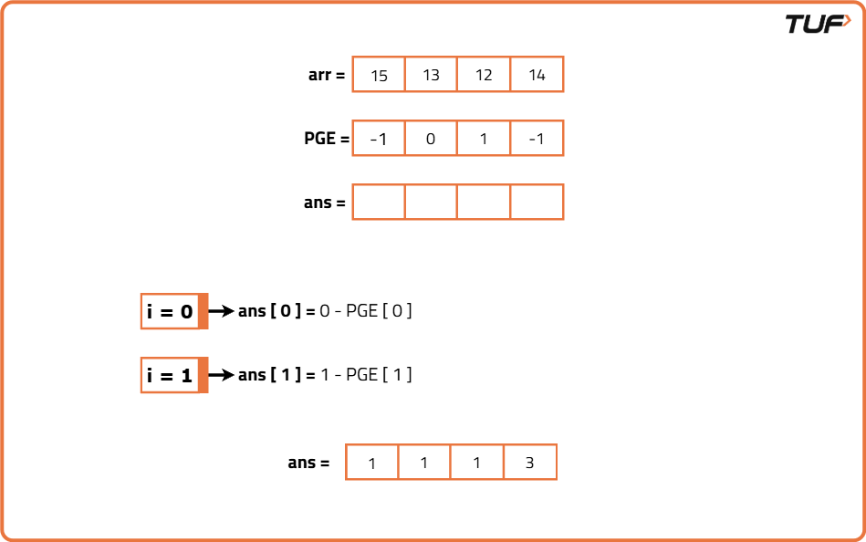

class Solution {

/* Function to find the indices of the previous
greater element for each element in the array */
private int[] findPGE(int[] arr) {
int n = arr.length;
// To store the previous greater elements
int[] ans = new int[n];
Stack<Integer> st = new Stack<>();
for (int i = 0; i < n; i++) {
int currEle = arr[i];
// Pop elements from the stack until we find a greater element
while (!st.isEmpty() && arr[st.peek()] <= currEle) {
st.pop();
}
// If the stack is empty, it means there's no greater element, so assign -1
if (st.isEmpty()) ans[i] = -1;
else ans[i] = st.peek();
st.push(i);
}
return ans;
}
public int[] stockSpan(int[] arr, int n) {
// Get the indices of previous greater elements
int[] PGE = findPGE(arr);
// To store the final span results
int[] ans = new int[n];
// Compute the span for each element using the previous greater element indices
for (int i = 0; i < n; i++) {
ans[i] = i - PGE[i]; // Calculate span based on previous greater element
}
// Return the result (stock span for each day)
return ans;
}
}
Time Complexity: O(N), since finding the indices of previous greater elements takes O(N) time and we traverse the array once to compute the stock span, that takes O(N) as well.
Space Complexity: O(N), the stack space used to find the previous greater elements can go up to O(N) in the worst case.

